Justin Marucci

Assignment 10

05/01/2025

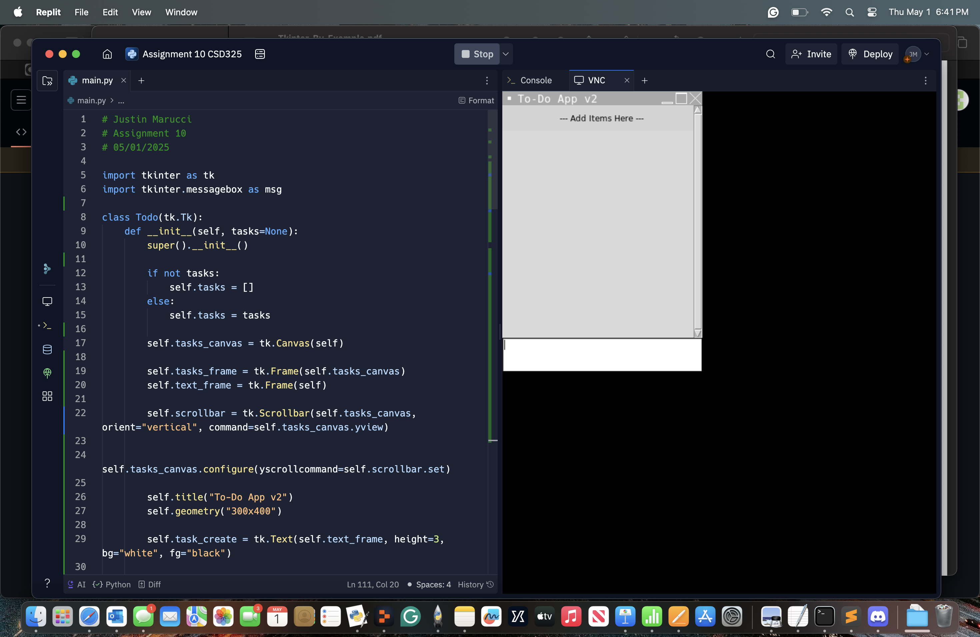

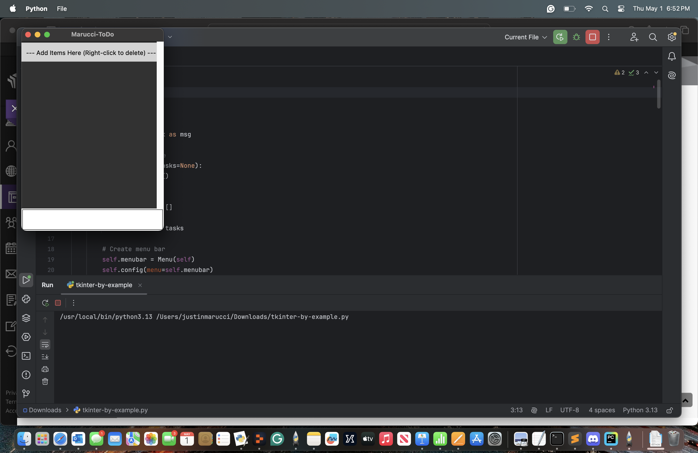Ran the updated version in Python because Replit took too long.